PETRA
Self Catering Holidays In Marazion
Petra is conveniently situated in the heart of Marazion a traditional Cornish Market Town. Marazion is famed as the departure point for internationally famous St Michael’s Mount.
Flats Located Above Seagrove Gallery
Petra is situated within a Grade II listed building above the beautiful and unique Seagrove Art Gallery. Located only a short flat walk to all local amenities which include, beaches, chemist, cash machine, general stores, post office, bakery, cafés, public houses, art galleries and antique shop.
Marazion makes an ideal base for visiting the rest of Penwith. This opens up even more recreational opportunities, such as walking the Cornish Coastal Path so enjoying the spectacular Cornish coastline of cliffs and remote coves. Visit the prehistoric sites for which this part of Cornwall has one of the highest concentrations in the country. With so much available, many of our guests discover that they need more than one holiday to fit everything in. With so many activities and places to visit there is sufficient to suit all tastes.
Causeway leading to St Michael’s Mount
Petra is only one minute walk from the causeway that leads to the internationally renowned St Michael’s Mount. The causeway is uncovered at low tide. When covered by the tide ferry boats are available.
There are numerous activities nearby including a museum and sailing club. The long gently sloping sandy beaches are ideal for beach lovers. Here on offer is kite surfing, wind surfing and sailing. On the outskirts of Marazion is Marazion Marsh a RSPB reserve. The reserve is open at all times and is renowned for its birdlife.
Marazion is served by a good bus service. There is a traffic free cycle path across the top of the beach, which one can follow to Penzance.

Ian & Sandra Seagrove
Seagrove Gallery, The Square, Marazion, Cornwall, TR17 0BH
Tel +44 (0)1736 710732
Tel +44 (0)1736 762228 Evenings
email:petra@marazionholidays.co.uk

FLAT 1
Non-Smoking Establishment


THE PROPERTY OFFERS:
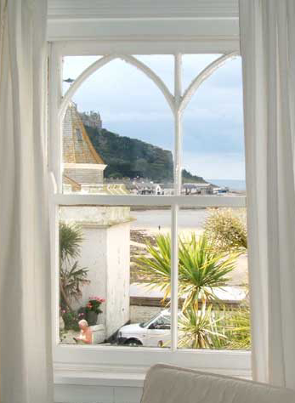
View from window overlooking St Michaels Mount

Wide entrance passage leading to;
Lounge/Diner with breathtaking views over St Michaels Mount. The room includes four seater dining table, comfortable sofa, T.V. Video and C.D. player.
Master Bedroom with kingsize bed.
Second Bedroom with two twin divans.
Bathroom with luxury corner bath and shower overhead, shaver socket, wc and washbasin. Hot water 24/7.
Well equipped Kitchen off the Lounge, with built under cooker, microwave, iron, ironing board, toaster, fridge, extractor, crockery, cutlery, cooking utensils, hob, washing machine and combi central heating boiler.
Car Parking, close to the flat.
Central Heating optional.
Cleanliness is assured, every effort being made to ensure a pleasant and relaxing stay.
TARIFF: We are open all year, our prices ranging from £ 330 in the low season to £ 680 in the high season.
Twin divan Bedroom |  | Double Divan Bedroom |  | Lounge From Kitchen
Lounge |  | Kitchen from Lounge |  | Bathroom

FLAT 2
Non-Smoking Establishment

THE PROPERTY OFFERS:
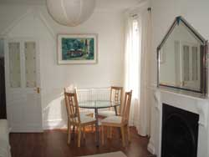
Dining Area
Entrance passage leading to;
Lounge/Diner with breathtaking views over St Michaels Mount. The room includes 3 seater dining table, comfortable sofa, LCD TV & DVD player.
Bedroom with a four poster Kingsize bed.
Well equipped Kitchen with built under cooker, microwave, iron, ironing board, toaster, fridge, extractor, crockery, cutlery, cooking utensils, hob, washing machine, and combi central heating boiler.
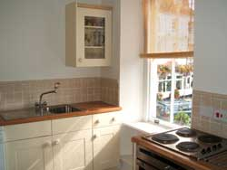
Kitchen
Bathroom with bath and shower overhead, shaver socket, wc and washbasin. Hot water 24/7.
Car Parking, close to the flat.
Central Heating optional.
Cleanliness is assured, every effort being made to ensure a pleasant and relaxing stay.
TARIFF:
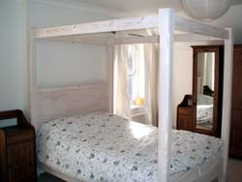
Four Poster Kingsize Bed
We are open all year, our prices ranging from £ 310 in the low season to £ 620 in the high season.
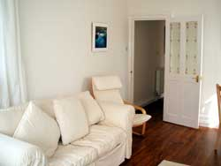
Lounge
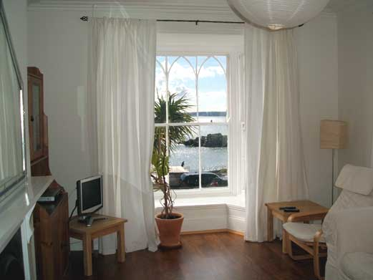
Lounge window overlooking St Michaels Mount & Mounts Bay

Location
DIRECTIONS:
On the A30 after leaving Crowlas, at the roundabout take the second exit which is signposted Marazion.
Bear right onto Newton Lane.
Bear left onto Local Road
Continue on this road and you will enter Marazion.
Bear right onto West End,
Turn left into The Square
The Seagrove Gallery is situated in the Square between Godolphin Arms and the Marazion Hotel.
Conditions Of Holiday Letting
1. A 25% deposit, with balance due 4 weeks before holiday commences.
2. Bookings run from 2pm SATURDAY UNTIL 10am SATURDAY.
3. Any breakages or damage to be paid for.
4. Linen supplied.
5. Please leave clean and tidy.
6. Please make your cheques payable to I.C.Seagrove.
7. Each flat has it's own electric slot meter which accepts £1 coins.
8. We operate a strict non-smoking policy in the Flats.
We regret that we cannot accommodate pets.
Tariffs
TARIFF: Flat 1 (2 bed) For 2012 Prices Are Per Week
 | - | January |  | To |  | 31 | - | March |  | £330 h
31 | - | March |  | To |  | 07 | - | April |  | £440 h
7 | - | April |  | To |  | 14 | - | April |  | £490 h
14 | - | April |  | To |  | 19 |  | May |  | £440
19 | - | May |  | To |  | 26 | - | May |  | £460
26 | - | May |  | To |  | 02 | - | June |  | £500
02 | - | June |  | To |  | 23 | - | June |  | £480
23 | - | June |  | To |  | 30 |  | June |  | £560
30 | - | June |  | To |  | 14 | - | July |  | £620
14 | - | July |  | To |  | 25 | - | August |  | £680
25 | - | August |  | To |  | 01 | - | September |  | £520
01 | - | September |  | To |  | 08 | - | September |  | £460
08 | - | September |  | To |  | 15 | - | September |  | £440
15 | - | September |  | To |  | 22 | - | September |  | £410
22 |  | September |  | To |  | 13 |  | October |  | £390 h
13 | - | October |  | To |  | 22 | - | December |  | £390 h
22 | - | December |  | To |  | 29 | - | December |  | £540 h

H after the amount means heating included, otherwise add £35 for heating

Tariffs
TARIFF: Flat 2 (1 bed) For 2012 Prices Are Per Week
 | - | January |  | To |  | 31 | - | March |  | £310 h
31 | - | March |  | To |  | 07 | - | April |  | £410 h
7 | - | April |  | To |  | 14 | - | April |  | £440 h
14 | - | April |  | To |  | 19 |  | May |  | £410
19 | - | May |  | To |  | 26 | - | May |  | £430
26 | - | May |  | To |  | 02 | - | June |  | £480
02 | - | June |  | To |  | 23 | - | June |  | £460
23 | - | June |  | To |  | 30 |  | June |  | £540
30 | - | June |  | To |  | 14 | - | July |  | £590
14 | - | July |  | To |  | 25 | - | August |  | £620
25 | - | August |  | To |  | 01 | - | September |  | £500
01 | - | September |  | To |  | 08 | - | September |  | £420
08 | - | September |  | To |  | 15 | - | September |  | £400
15 | - | September |  | To |  | 22 | - | September |  | £380
22 |  | September |  | To |  | 13 |  | October |  | £360 h
13 | - | October |  | To |  | 22 | - | December |  | £360 h
22 | - | December |  | To |  | 29 | - | December |  | £520 h

H after the amount means heating included, otherwise add £35 for heating

